INSTRUCTIONS

At the end of your four-year cycle, you will be asked to submit a list of your Continuing Education Hours (CEHs). You will use the following form to report your CEH activities, which when completed should be submitted to the TECUnit at info@tecunit.org.

WHEN DOES MY FOUR-YEAR CYCLE END?
Every nationally certified cued language transliterator has been assigned a group by year of certification. You can determine your group by looking at the letter preceding your CLTID number.

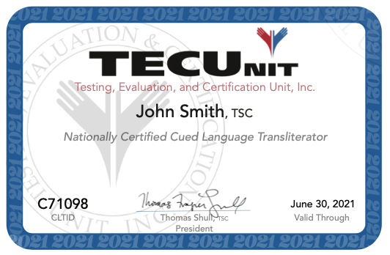

This table shows you in which years on June 30th, reporting of your CEH activities is due.

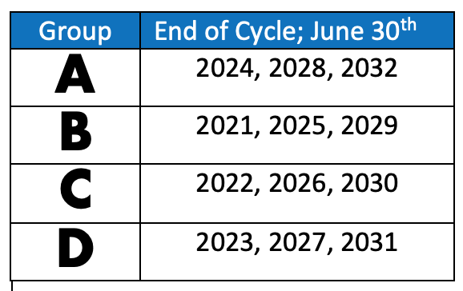

SHOULD I SEND ALL MY CERTIFICATES WITH THIS FORM?
No. You do not need to submit any additional documentation with the CEH Reporting Form. Your list will be compared to the Participant Forms submitted by CEH Sponsors and to any certificates you already submitted for Unsponsored Events you had approved and have completed. You will only be asked to submit certificates in cases where discrepancies occur.

It is important that you make sure you receive a certificate/proof of attendance for every CEH event you complete and that you retain these certificates in your records.

WHAT IF I DON’T THINK I WILL BE ABLE TO MEET THE REQUIREMENT BY THE END OF MY CYCLE?
If for any reason you think you will be unable to meet any of the requirements for the Certification Maintenance Program, contact the TECUnit immediately. We will do our best to advise and support you. However, when TSC holders notify us just prior to the deadline, there is little we support we can provide.

IS IT POSSIBLE TO RECEIVE AN EXTENSION?
Yes. Nationally certified CLTs may request a once-in-a-lifetime extension for CMP requirements. Refer to www.tecunit.org for more information and the request form.

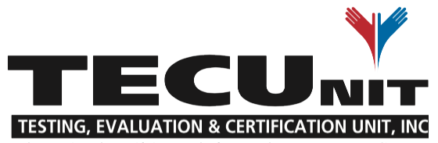
Continuing Education Hour Reporting Form

Name: _________________________________ CLTID: ________________

Event Title | Completion Date | Sponsor | Hours Earned*
 |  | TOTAL HOURS
*Do not round CEHs

